Smoke Lessons
2/9/22
Trent Wickman

Lessons
- Using Wind Roses to Assess Tradeoffs with Wind Direction Windows
- Using Forecast Soundings to Get a Better Picture of the Smoke Rise and Transport at Your Location
- Using Trajectories to Determine Smoke Transport and Culpability for a Smoke Event
- Using a Simple Smoke Model to Assess the Impact of a Burn
- Using a Second Level Smoke Model to Assess the Impact of a Burn

Lesson Title: Using Wind Roses to Assess Tradeoffs with Wind Direction Windows
Objective: Student will be able to use wind roses to assess the impact of removing wind from different sectors on the probability of being able to accomplish the burn
Website: https://mesonet.agron.iastate.edu/sites/locate.php?network=MN_ASOS
Problem Statement: You are planning a burn near Grand Rapids for the month of April. You have sensitive receptors southeast and southwest of the burn. Would taking the problematic wind directions out of the prescription significantly impact the chances of burning?
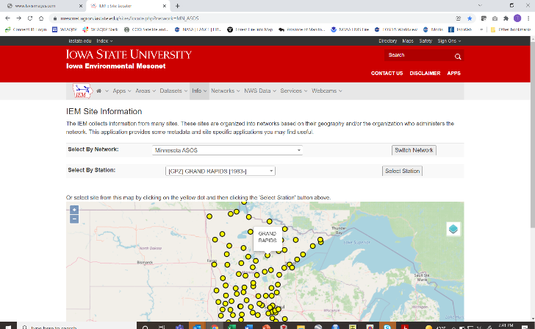
- Click on the dot on the map corresponding to “Grand Rapids” or pick it from the drop down menu
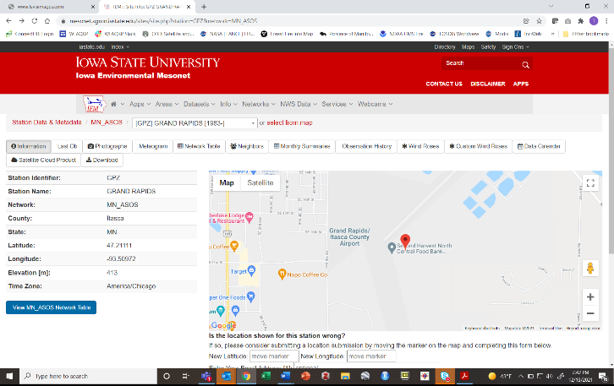

- Click on the dot on the wind roses tab
- Scroll down on the page that appears. The first big circular chart is the annual wind rose and below that are monthly wind roses.
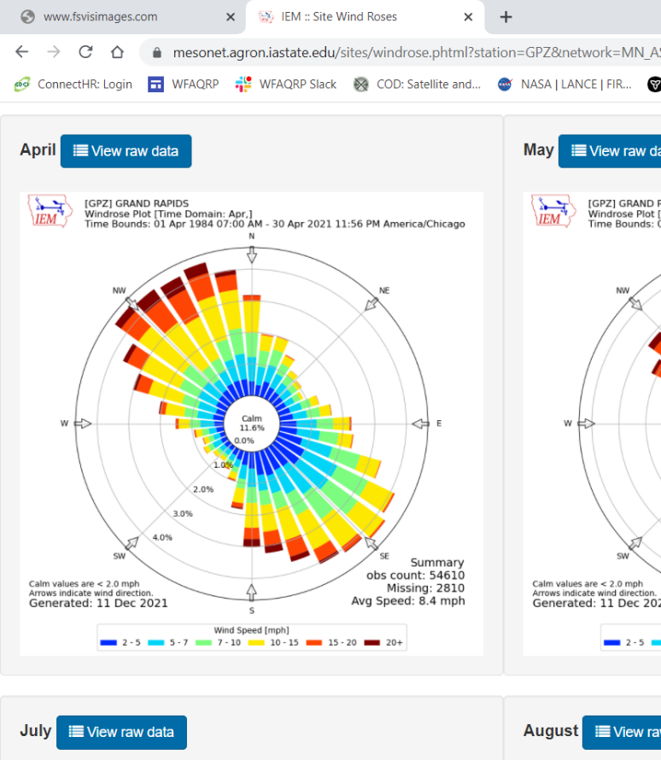
These circular graphs are called wind roses because some people think the look like flowers. All the hours from every April from 1984 to 2021 were included.
To interpret a wind rose the first thing to notice is that some of the rays are longer than others. The longer the ray, the more often the wind COMES FROM that direction. In the example above, the wind comes predominantly from the NW and SE. To find out just exactly how often the wind come from any particular direction look at the labels on the rings that run to the SW. There are rings at 1, 2, 3, 4%. In the very center it says “Calm 11.6%” which means that the wind is calm 11.6% of the time. If we take the rays that run on either side of the NW line they extend about hallway past the 4% - so say 4.5%. If you add up the length of all the rays plus the 11.6% for calm it should total 100%. There are 36 rays in this wind rose. The number of rays is determined by the user. Fewer rays can make the wind rose simpler to use.
Looking at your sensitive receptors you have some to the southwest and some to the southeast. Let’s consider those to the southeast first. Let’s say you want to be very conservative and eliminate any wind direction from the prescription that could possibly bring smoke near them.
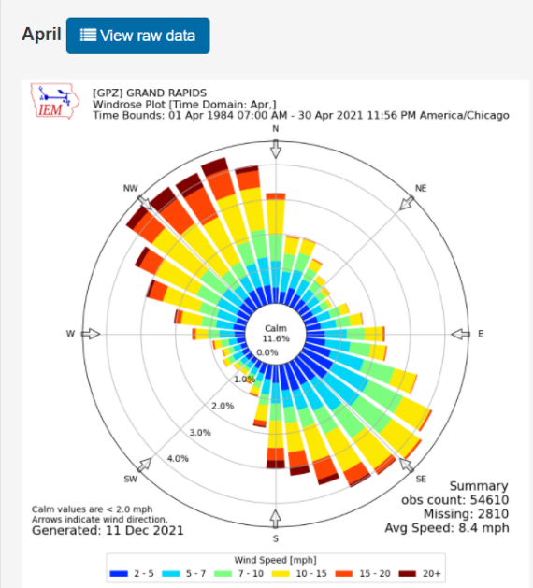
Let’s eliminate the rays in the triangle. They are roughly, (going clockwise): 3, 3.5, 4.5, 4.5, 4.5, and 4.5% which total 24.5%. That, along with the 11.6% that is calm, means that you have a: 100 – 24.5 – 11.6 = 64% chance of getting the wind you need. Removing the NW winds from the prescription dropped the probability of getting the wind you need from 88% (100 – 11.6) to 64%.
In the case of the sensitive receptors to the southeast, the wind rose shows that winds from the northeast are uncommon. Adding the rays in the triangle we get: 2, 1.5, 1, 1, 1, 1.5% which equal 8%. So, in this case removing these wind directions only reduces the probability of getting the wind you need from 88% (100 – 11.6) to 80%.

A couple other notes:
There are other networks to choose from when you begin. Click on the dropdown menu under “Select by Network.” Be sure you select a station that has a good amount of historical data ~ 20+ years.
The colors of each ray indicate for that wind direction what the distribution of wind speeds was. The key is below the chart.
More sophisticated wind rose programs allow you to choose any amount of time to process. For example you could process April 15 thru June 1 and only the hours of 1000 through 1700 because that may more accurately reflect when you burn.
Exercise:
Now do a wind rose for a burn on your home unit that has sensitive receptor concerns. If you remove the winds in the direction of the receptors from the prescription, will you strongly impact the probability of getting your burn off?

Lesson Title: Using Forecast Soundings to Get a Better Picture of the Smoke Rise and Transport at Your Location
Objective: Student will be able to use forecast upper air soundings to predict how high smoke from a burn will rise and be dispersed
Website: https://rucsoundings.noaa.gov/
Problem Statement: Atmospheric stability and the wind profile through the lower atmosphere is critical to determining the transport of smoke. Many tools only give this information for a few points in time and have trouble representing the complexity with a few numbers or metrics. Stability and upper winds are constantly changing though the day. By using sounding a burn boss can visualize the dynamics of these changes and identify critical points for their burn.

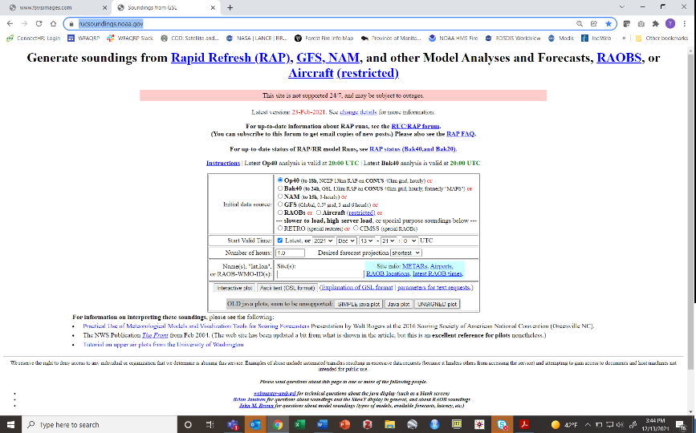

- Enter the start time for your sounding. It is helpful to see how the atmosphere is setting up a few hours before you start lighting. The time is Greenwich Mean time (also know as UTC) so you will need to convert your local time to UTC. This is usually around 5-6 hours difference but look it up online to be sure you have it correct for your time zone and if you are on daylight savings or not.
- You can only go forward in time as far as 48 hours. So, if your start time is 36 hours in the future you can only get forecasts for about 12 hours forward from that point in time.
- You can get outputs for as many as 20 hours so go with 20
- You put in the latitude and longitude of the burn in DECIMAL DEGREES. Not degrees and decimal minutes. Nothing else will work. Converting to decimal degrees can be done easily online.
- Longitude MUST be negative. For example, for Grand Rapids you would enter “47.2372,-93.5302” NO SPACES
- Click interactive plot
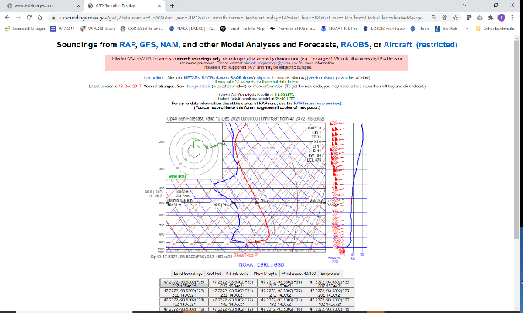
- DON’T FREAK OUT!
- Click on “Simple Plot”
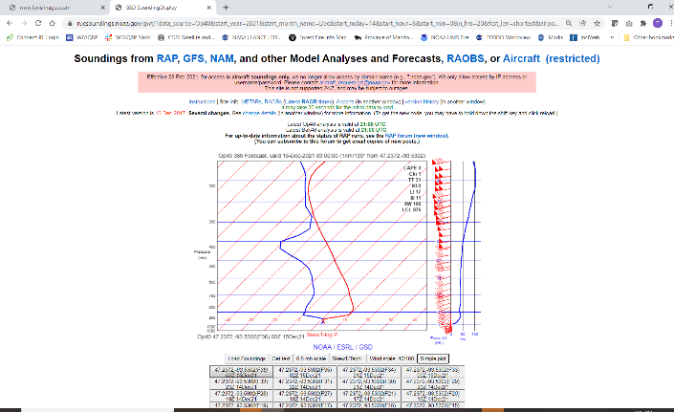
- The boxes below the graph represent hour by hour charts with the oldest to the bottom right. They are labeled in UTC. The one showing should be the last hourly prediction.
- These charts are used by forecast meteorologists so they can appear to be VERY complicated, but we are just looking to understand a couple basic things.
- The Y-axis is height above mean sea level. It is measured in pressure instead of feet. To get the height in feet hover over the graph and it will appear with a lot of other weather data at that height. The sounding starts at ground level for the location entered.
- The X-axis is temperature (Celsius) but it is on a tilt (or skew).
- The red line is the dry bulb temperature, the blue line is the wet bulb temperature.
- Along the right side of the graph are two different ways to represent the wind speed and wind direction. The wind barbs show the direction the wind is coming from. The more barbs on the tail the faster the wind. The wind speed is in knots which are roughly equal to miles per hour (1 knot = 1.15 miles per hour).
- If you click through the boxes, starting with the oldest in the bottom right, you can see how the temperature and winds will change through the day as the sun rises and warms the earth and as fronts and other weather events pass.
- Stability: the importance of stability should be obvious from your prior training and field experience. We will focus on the very lowest elevation on the chart to determine stability. The stability is determined by the dry bulb (red) line. In general, the following rules apply:
  - Sections of the red line that slope up and to the right are STABLE. They are showing air that gets warmer as you go up in the atmosphere.
  - Sections of the red line that slope up and to the left are UNSTABLE. They are showing air that gets warmer as you go up in the atmosphere.
  - The steeper the lines slope, the more extreme the stability or instability. The break point between the two is termed neutral. You might assume it is a vertical line, but it is actually tipped slightly to the left as you go up.
- Mixing Height: given the absence of other larger events, as the land warms during the day the lower level of the atmosphere warms too. This will produce an UNSTABLE temperature profile in the lower atmosphere. At some point as you start at the ground and look up in elevation the temperature profile will bend back to the right. It is at this point that an inversion exists, and this is the mixing height. If you hover over this point, the height in feet will be displayed.
- Transport Winds: transport wind speed and direction is defined as the average of the wind speed and direction in the mixed layer. Since we just defined the mixing height, all the windspeed below this location to the ground would be averaged to give the mixing height. Often the wind direction will spin as you move up in the atmosphere. This is good to know because then you can predict where your smoke is going depending on how much lift you get from your ignition strategy.
- Strength of the Inversion/Mixing Height: it is possible to punch through the inversion that defines the mixing height depending on:
  - how strong of lift your get (i.e. how much heat you generate and how quickly) and
  - how strong the inversion is.
The strength of the inversion will depend on the steepness of the slope of the inversion above the mixing height and its thickness.
- Wind Above the Mixing Height: a key piece of information that is usually not given in a spot forecast is the wind direction and speed above the mixing height. If you punch through the mixing height, the winds above it will determine where your smoke is going to travel and at what speed. These winds also could mix down to the surface if the inversion is not strong and become your surface wind gusts in the afternoon. If their direction or dryness could be problematic, this is good situational awareness.

Exercise:
Now do a sounding for a burn on your home unit for tomorrow. Is it a good day to burn? Determine the parameters discussed above from the sounding. Are any of these a concern?
Extra Credit:
Will you meet the MN SMP guidelines for the necessary dispersion index?

Lesson Title: Using Trajectories to Determine Smoke Transport and Culpability for a Smoke Event
Objective: Student will be able to use trajectories to estimate the transport of smoke from a current day burn and to assess their culpability for a past smoke event.
Website: https://www.airnowtech.org/index.cfm?page=login
Problem Statement: Determining the transport direction of smoke is a basic consideration before lighting the match. Trajectories are good at this. It must be remembered that trajectories don’t determine the concentration of smoke in the atmosphere, just the direction it may go. The distance along this path that smoke will go is dependent on the size and fuel load of the burn. This question can be answered best by a dispersion model. Trajectories are unique in that they can be run backward in time. This is useful to assess the direction from which air came from when an event happens, such as a smoke event in a sensitive location.
- Login to airnow-tech. If you have not registered, you must do this first
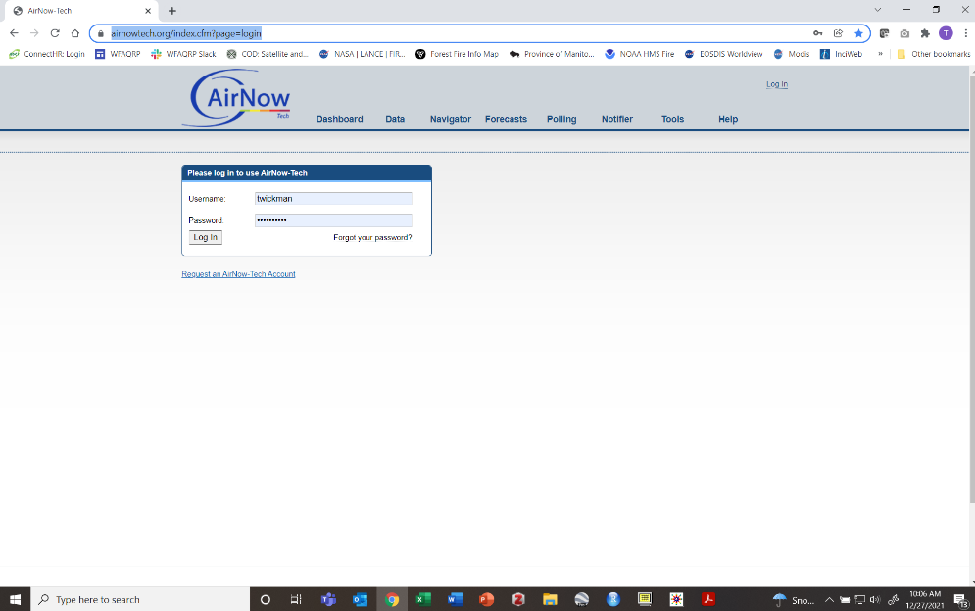

- Click on Navigator
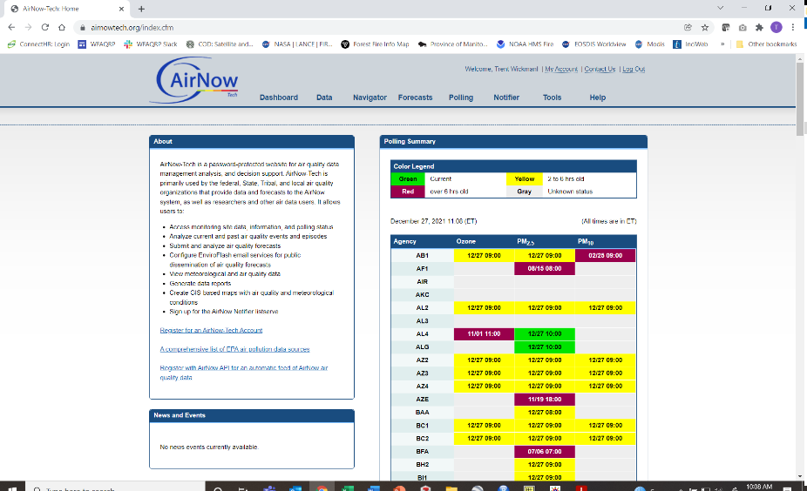

- You may need to zoom and pan the map to get it to where you want. You can save this view once you get what you like by selecting the “My Maps” tab in the upper right of the screen
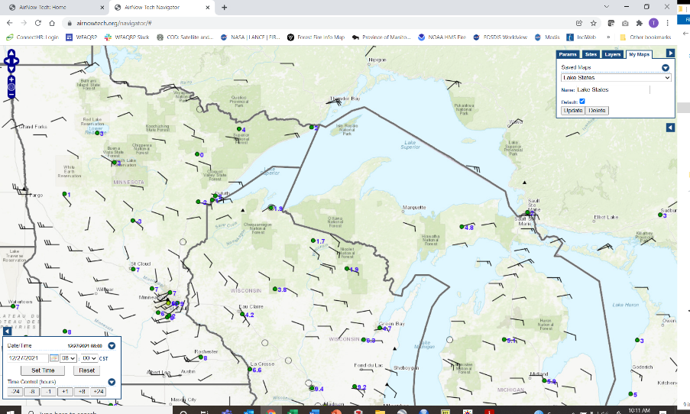
- The other tabs toggle on and off many layers that provide good information. Feel free to experiment. I’d suggest:
  - PM2.5 – Principal – PM25
  - HMS smoke
  - HMS fire
  - Wind Barbs
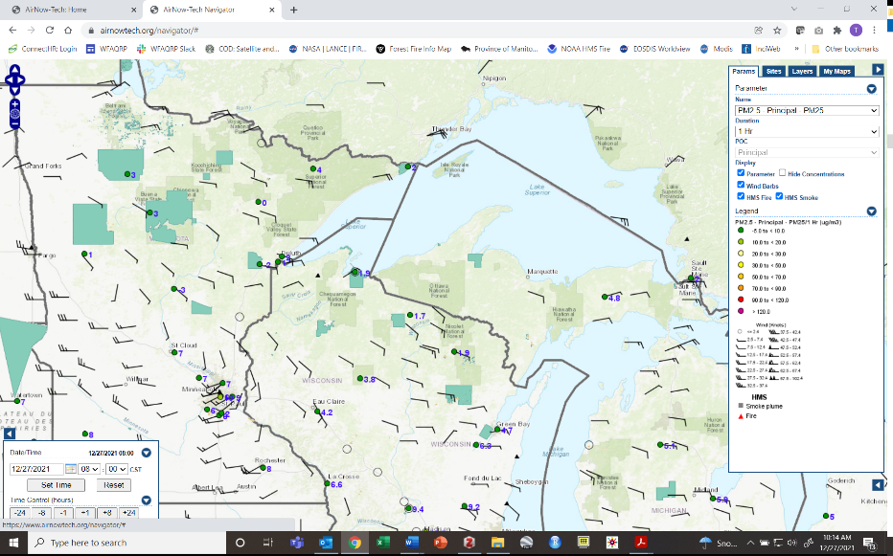
- To get started click on the little left arrow box near the right bottom of the screen
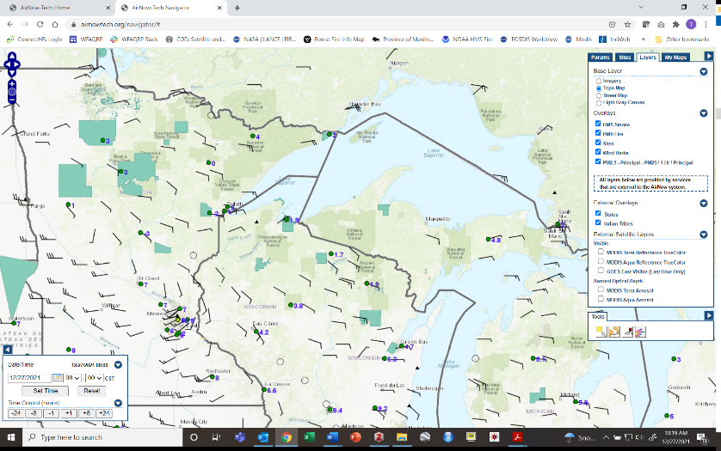
- Click on the box that has the little red box with lines coming out of it. If you hover over it, it will say ”HYSPLIT Tool”
- You will probably have to scroll the screen down to see all the new entry boxes
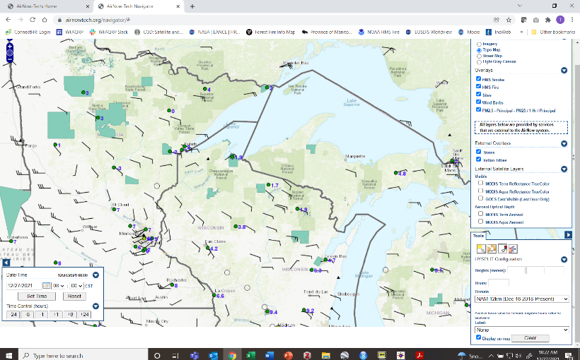
- To do a trajectory the computer needs to know 3 things
  - Latitude and longitude
  - Height
  - Time

DAY OF THE BURN EXAMPLE
- You can enter up to 3 starting heights to run at the same time. Try to pick heights that bracket the plume rise you think you will get. It may also be a good idea to set one above the expected mixing height if you think you may punch through it. The heights need to be entered in meters so you need to convert (~3 ft = 1 m)
- 24 hours is usually good
- Set the time in the lower left box to when you want it to start. You can’t go more than a day or two into the future. Be sure to click the “Set Time” button when done
- Leave the domain
- Choose a label that suits you. I think Hour and Height are the most useful
- Click on the map the location of your burn
- Wait a minute or two
- You will have one line for each height you entered (up to 3)
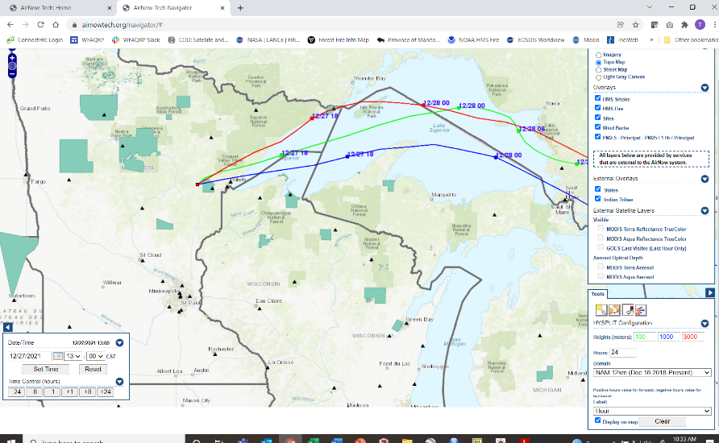
- In my example you see the trajectories go off the map. If the burn you were considering was a 40-acre grass burn, would you expect it to send smoke across Lake Superior?
BACK TRAJECTORY EXAMPLE
- This case is one where you were accused or are wondering if you contributed to a smoke event at a certain location on a certain day
- Pick the date of the event. This program can go pretty far back in time – looks to be January 2015 currently
- For Height, in this case we mean arrival height. If it affected people, it was probably at approximately ground level, so 100 m is a good number.
- For time enter “-24” to indicate you want it to go back in time
- For domain – if your date is before dec 16 2018, select the “NAM 40 km”
- It is important to do multiple runs around the time you selected; so maybe 2-3 hours before and 2-3 hours after. You can keep laying these runs on top of each other.
- If you want to clear the runs and start over click the “Clear” button on the bottom right
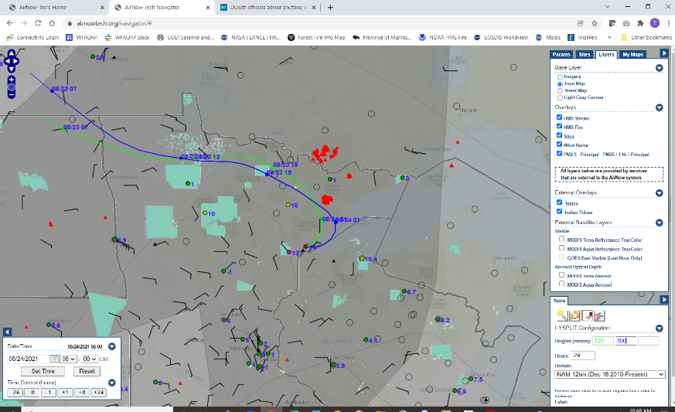
- The example shown is for the morning of 8/24/21 which was a severe smoke day in Duluth. The trajectories can be seen to skirt the Greenwood fire
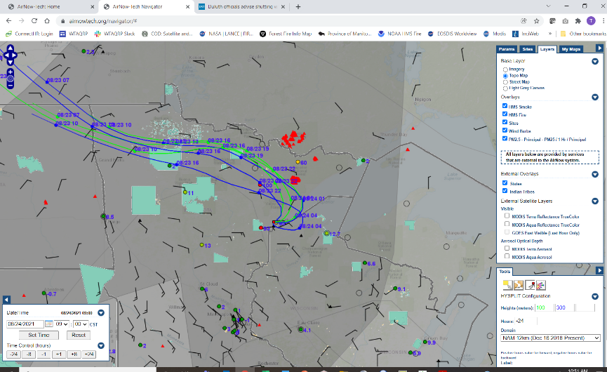
I added 2 more runs; one 3 hours before and another 3 hours after the original run. Just because the trajectories don’t go directly over the fire doesn’t mean it didn’t contribute. Smoke was likely in air around the fire from previous days. Smoke for other fires was also in the air in the general area.

Lesson Title: Using a Simple Smoke Model to Assess the Impact of a Burn
Objective: Student will be able to use a simple dispersion model for a current day burn to assess the downwind distance and potential severity of their smoke.
Website: http://fireweather.fdacs.gov/Simple-Smoke/
Problem Statement: Determining the distance downwind that smoke will travel is dependent on the size and fuel load of the burn. This question can be answered best by a dispersion model. Dispersion models vary widely in complexity. To be most efficient it is best to start with simple dispersion models with few inputs to quickly screen a burn to determine if it has the potential for serious impacts and if so then to move to more complex models
- Navigate to the site

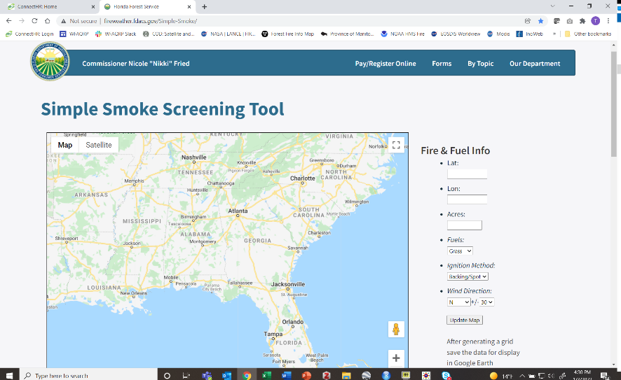
- There are 6 parameters to enter. Fill these in and click on “update map”. Remember that latitude and longitude need to be in decimal degrees and longitude needs to be negative.
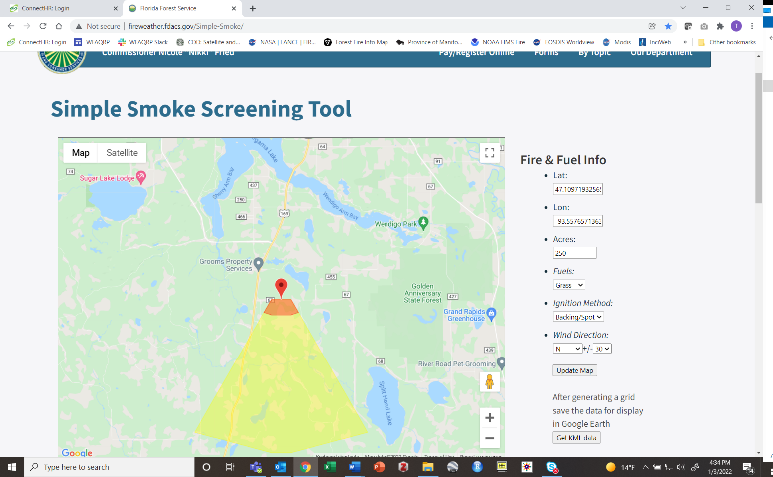

- While the colored output appears to be concentration contours – it is not. Since this is a screening model it gives qualitative results. I interpret the colors to mean:
  - Orange - highest impacts, focus your smoke management activities in this area
  - Yellow - people here will see smoke but it won’t be a major problem
- Rerun multiple times choosing wind directions that vary from most desired to least desired (unless this wind direction has been eliminated in your prescription) to get a sense for the potential impacts.
- If you want more specific information and/or your burn has the potential to cause unacceptable impacts you may want to move to the next most complex model – VSMOKE

Lesson Title: Using a Second Level Smoke Model to Assess the Impact of a Burn
Objective: Student will be able to use a simple dispersion model for a current day burn to assess the downwind distance and potential severity of their smoke.
Website: http://weather.gfc.state.ga.us/googlevsmoke/vsmoke-good2.html
Problem Statement: Determining the distance downwind that smoke will travel is dependent on the size and fuel load of the burn. This question can be answered best by a dispersion model. Dispersion models vary widely in complexity. To be most efficient it is best to start with simple dispersion models with few inputs to quickly screen a burn to determine if it has the potential for serious impacts and if so then to move to more complex models
- Navigate to the site
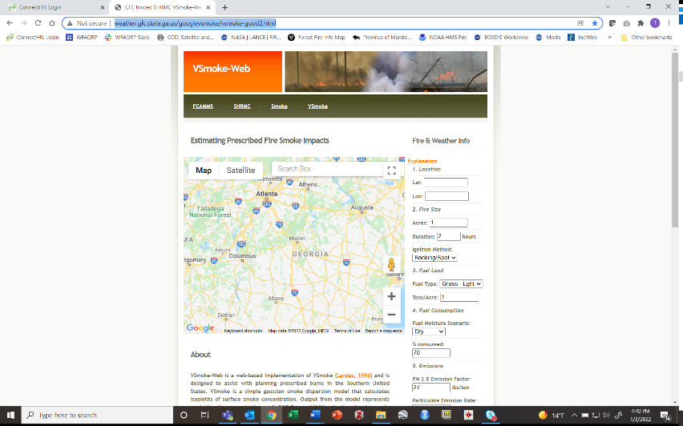
- This model requires quite a bit more input data than the screening model. It runs down the right side of the window. Most are self-explanatory. A few notes:
  - Latitude, longitude - remember that latitude and longitude need to be in decimal degrees and longitude needs to be negative.
  - Duration – is duration of lighting
  - No need to enter anything for
    - % consumed
    - Section 5 – Emissions
    - Section 8 - Misc Options
    - Section 9 – Hysplit Info
  - Everything in “Section 6 Weather” can affect your results. These values can be found in your spot weather report except for stability class which can be left as is. If you are running the model in planning mode – well ahead of burn day – you may want to select a group of “worst case” weather values and then also “typical case” values.
- Click on “Run Model”
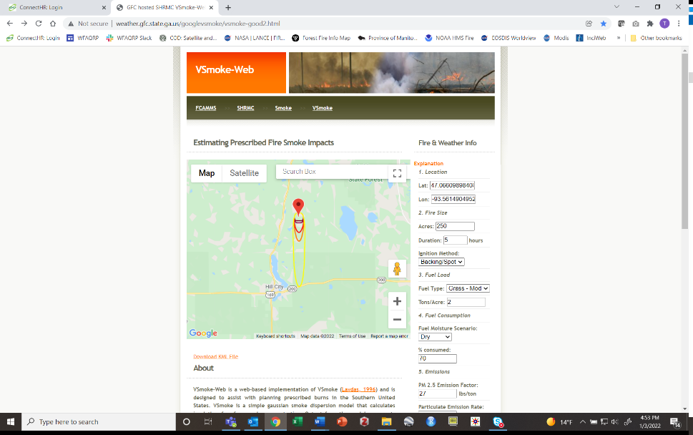
- You should see a set of concentric ovals. You will see more and darker circles the stronger the smoke plume. The colors correlate with the Air Quality Index (AQI) at the bottom of the page.

